Business Requirement Document (BRD)
HCL Infra Team Project KRA Tracker
Version: 2.0
Date: April 21, 2026

1. Executive Summary
The HCL Infra Team Project KRA Tracker is proposed as a centralized web-based application to manage, monitor, review, and report Key Result Areas (KRAs) across infrastructure projects, distributed sites, reporting hierarchies, and management levels.
At present, KRA tracking is managed through spreadsheets, manual reporting, fragmented email communication, and meeting-based status reviews. This approach creates multiple operational gaps, including limited visibility, inconsistent reporting formats, absence of audit trails, delays in escalation, and challenges in measuring individual and project performance in real time.
The proposed system will replace these manual processes with a structured digital platform that enables:
- Centralized KRA creation and assignment
- Real-time task and milestone tracking
- Multi-level review and approval workflow
- Structured employee-manager-HO collaboration
- Dashboards for operational and strategic visibility
- Audit-ready reporting and management controls
- Performance measurement aligned with business goals
The system is intended not only as a task tracker, but as a performance governance platform for project execution.

2. Business Objective
The primary business objectives of this initiative are:

2.1 Digitize KRA Management
Replace manual Excel-based tracking with a centralized system.

2.2 Improve Visibility
Provide real-time visibility of:
- KRA status
- Delays
- Risks
- Pending approvals
- Resource performance
- Site-level execution progress

2.3 Strengthen Accountability
Create ownership at every level:
- Employee accountability for execution
- Manager accountability for monitoring
- HO accountability for strategic oversight

2.4 Standardize Reporting
Ensure a common process and reporting format across all projects and sites.

2.5 Improve Decision Making
Provide data-driven inputs for:
- Escalations
- Resource planning
- Performance reviews
- Strategic decisions

3. Project Scope

In Scope
The proposed system will include:

User Management
- User registration
- User provisioning
- Role assignment
- Hierarchy mapping

Project Management
- Project creation
- Site creation
- Site-project mapping
- Team allocation

KRA Management
- KRA creation
- KRA assignment
- Milestone definition
- Progress tracking
- Due date monitoring
- KRA closure

Workflow Management
- Comment workflow
- Review workflow
- Escalation workflow
- Approval workflow

Reporting
- Dashboards
- Reports
- Analytics
- Export functionality

4. Stakeholders
Stakeholder | Role | Responsibility
Employee | End User | Update KRAs, report progress
Reporting Manager | Reviewer | Assign, review and monitor KRAs
HO Personnel | Senior Oversight | Strategic review and escalation
HOD/Admin | System Owner | Governance and approvals
IT Team | Technical Support | Maintenance and support

5. User Roles and Access Matrix

5.1 Employee Access
Employee should be able to:
- View assigned KRAs
- Update progress
- Add status comments
- Upload supporting documents
- View manager feedback
- View deadlines
- Raise risks or blockers

5.2 Reporting Manager Access
Manager should be able to:
- Create KRAs
- Assign KRAs
- Edit target dates
- Review employee updates
- Add manager comments
- Escalate issues
- Approve or reject closures
- View team dashboard

5.3 HO Access
HO should be able to:
- View all projects
- Add HO comments
- Review escalations
- Track risks
- View consolidated dashboards
- Review performance trends

5.4 Admin/HOD Access
Admin should be able to:
- Manage users
- Configure hierarchy
- Manage system masters
- Manage permissions
- Override approvals
- Access audit logs
- Generate executive reports

There will be multiple screens and modules. For understanding purpose find the
Head Office KRA Screen
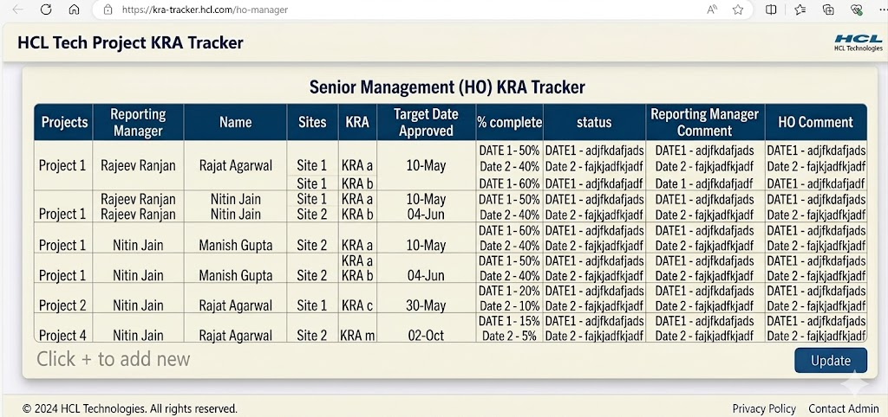

6. Detailed Functional Requirements

Module 1 — Login and Authentication

Features

Secure Login
- Email-based login
- Password authentication
- Password reset
- Account lock after failed attempts

Security Controls
- Role-based access
- Session timeout
- Password policy
- User activity logs

Module 2 — User & Hierarchy Management

Features

User Master
Fields:
- Employee ID
- Employee Name
- Email
- Designation
- Department
- Reporting Manager
- Site
- Project Mapping
- Status

Hierarchy Mapping
System must support:
Employee → Manager → HO → HOD
With:
- Multi-level reporting
- One-to-many reporting structure
- Dynamic hierarchy changes

Module 3 — Project & Site Management

Project Setup
Fields:
- Project ID
- Project Name
- Project Type
- Start Date
- End Date
- Status
- Project Owner

Site Setup
Fields:
- Site Name
- Location
- Region
- Site Code
- Assigned Team

Module 4 — KRA Management

KRA Creation
Fields:
- KRA Title
- KRA Description
- Priority
- Weightage
- Target Date
- Assigned To
- Site
- Project
- KPI/Measurement Metric

KRA Status Options
- Not Started
- In Progress
- At Risk
- Delayed
- Completed
- Closed

Progress Updates
Employee should update:
- Percentage completion
- Current status
- Issues/blockers
- Next action
- Revised target date request

Module 5 — Comment Workflow

Employee Comment Section
Should capture:
- Progress update
- Risk update
- Support required
- Meeting discussion notes
- Timestamp

Manager Comment Section
Should capture:
- Feedback
- Direction
- Escalation remarks
- Corrective action
- Review date

HO Comment Section
Should capture:
- Strategic remarks
- Intervention comments
- Escalation decision
- Final review observations

Module 6 — Approval Workflow
Workflow:
- Employee submits update
- Manager reviews
- Manager approves or sends back
- Escalation to HO if required
- HO review
- Final closure approval

Module 7 — Alerts & Notifications
System should trigger notifications for:

Automated Alerts
- New KRA assignment
- Upcoming due dates
- Overdue KRAs
- Pending approvals
- Escalated tasks
- Comment updates

Notification Channels
- In-app notifications
- Email alerts

7. Dashboards and Reporting

Project Dashboard
Should display:
- Total KRAs
- Completed KRAs
- Pending KRAs
- Delayed KRAs
- Risk KRAs
- Completion %

Employee Dashboard
Should show:
- Assigned KRAs
- Completed KRAs
- Pending KRAs
- Overdue KRAs
- Individual performance score

Manager Dashboard
Should show:
- Team performance
- Delayed tasks
- Pending approvals
- Escalation summary

Site Dashboard
Should show:
- Site-wise performance
- Site comparisons
- Site risk indicators

Executive Dashboard
Should show:
- Cross-project performance
- Resource productivity
- High-risk KRAs
- Strategic escalations
- Trend analysis

8. Reports Required
System should support:

Operational Reports
- Daily status report
- Weekly KRA report
- Monthly performance report

Management Reports
- Delayed KRA report
- Escalation report
- Risk report
- Site performance report

Audit Reports
- User activity logs
- Comment history
- Approval trail
- Change logs

9. Search, Filter and Sorting
Users should be able to filter by:
- Project
- Site
- Employee
- Manager
- Priority
- Status
- Due date
- Delay category
Search should support:
- Keyword search
- KRA ID search
- Employee search

10. Audit Trail Requirements
System should record:
- Who created KRA
- Who modified KRA
- When updated
- Previous value vs new value
- Approval actions
- Comment history
This is critical for compliance and governance.

11. Non-Functional Requirements

Performance
- Response under 10 seconds
- Support concurrent users
- Scalable for future growth

Security
- Role-based access control
- Encrypted passwords
- Secure sessions
- Audit logs
- Data access restrictions

Availability
- 99.5% uptime target

Usability
- User-friendly interface
- Minimal training requirement
- Simple navigation

12. Data Requirements

Master Data
- Employee master
- Project master
- Site master
- KRA master
- Role master

Transaction Data
- KRA updates
- Comments
- Progress records
- Approvals
- Escalations

13. Risk Management Requirements
System should track:
- KRA risks
- Severity
- Risk owner
- Mitigation plan
- Escalation date

14. Assumptions
- Users will have system access.
- Organization hierarchy is defined.
- KRA measurement logic is agreed.
- Management approval process exists.

15. Dependencies
Project depends on:
- User master data availability
- Hierarchy data availability
- Infrastructure availability
- User training
- UAT signoff

16. SERVER Requirement – AWS Cloud or similar
- Server Type – AWS EC2
- RAM – 8 GB (Min)
- Storage – 100 GB

17. SERVER Management and Maintenance
- Customer or the team can take the AWS or azure or google server or provide us the same for Linux.

